A KEY HITLER SPEECH ON ART
Nuremberg, 6 September 1938
Excerpts - Not Complete
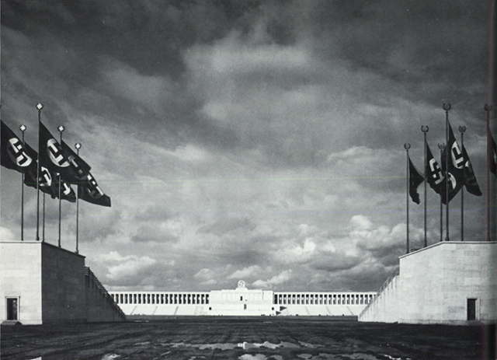
The proof of the endowment of a true artist is always to be found in the fact that his work of art expresses the general will of a period. Perhaps that is most clearly shown in architecture .... The religious mystical world of the Christian Middle Ages, turning inwards upon itself, found forms of expression which were possible only for that world. A Gothic stadium is as unthinkable as a Romanesque railway station or a Byzantine market hall. The way in which the artist of the Middle Ages, of the beginnings of the modern world, found the artistic solution for the buildings which he was commissioned to create is in the highest degree striking and admirable.
That way, however, is no evidence that the conception of the content of life held by the folk of his day was in itself either absolutely right or absolutely wrong. It is evidence only that works of art have rightly mirrored the inner mind of a past age. It is therefore quite comprehensible that insofar as the attempt is made to carry on the life of that past age, those who search for solutions of artistic problems can still seek and find there fruitful suggestions.
CONTRADICTION BETWEEN CHRISTIAN ART AND NATIONAL SOCIALIST ART
Thus one can easily imagine that, for instance, in the sphere of religion men will always work backwards to the form-language of a period in which Christianity appeared to meet every need.
On the other hand, at the present moment, the expression of a new view of the world which is determined by the conception of race will return to those ages which in the past have already possessed a similar freedom of the spirit, of the will, and of the mind.
THE IMPORTANCE OF ROME
Thus, naturally, the manifestation in art of a European conception of the State will not be possible through civilizations, as, for example, the civilizations of the Far East, which -- because they are foreign to us -- have no message for our day. By contrast we shall be influenced in a thousand ways through the evidences and memories of that mighty imperial Power of antiquity which, although in fact destroyed fifteen hundred years ago, still as an ideal force lives on and works on in the imaginations of men. The more nearly the modern State approaches to the imperial idea of the ancient world-power, so more and more will the general character of that civilization be manifested in its influence upon the formation of the style of our own day.
National Socialism is not a cult-movement -- a movement for worship; it is exclusively a "volkic" political doctrine based upon racial principles. In its purpose there is no mystic cult, only the care and leadership of a people defined by a common blood-relationship. Therefore we have no rooms for worship, but only halls for the people -- no open spaces for worship, but spaces for assemblies and parades.
We have no religious retreats, but arenas for sports and playing-fields, and the characteristic feature of our places of assembly is not the mystical gloom of a cathedral, but the brightness and light of a room or hall which combines beauty with fitness for its purpose. In these halls no acts of worship are celebrated, they are exclusively devoted to gatherings of the people of the kind which we have come to know in the course of our long struggle; to such gatherings we have become accustomed and we wish to maintain them. We will not allow mystically-minded occult folk with a passion for exploring the secrets of the world beyond to steal into our Movement.
Such folk are not National Socialists, but something else -- in any case, something which has nothing to do with us. At the head of our program there stand no secret surmising but clear-cut perception and straightforward profession of belief. But since we set as the central point of this perception and of this profession of belief the maintenance and hence the security for the future of a being formed by God, we thus serve the maintenance of a divine work and fulfill a divine will -- not in the secret twilight of a new house of worship, but openly before the face of the Lord.
There were times when a half-light was the necessary condition for the effectiveness of certain teachings: we live in an age when light is for us the fundamental condition of successful action. It will be a sorry day when through the stealing in of obscure mystic elements the Movement or the State itself issues obscure commissions ....
It is even dangerous to issue any commission for a so-called place of worship, for with the building will arise the necessity for thinking out so-called religious recreations or religious rites, which have nothing to do with National Socialism. Our worship is exclusively the cultivation of the natural, and for that reason, because natural, therefore God-willed. Our humility is the unconditional submission before the divine laws of existence so far as they are known to us men: it is to these we pay our respect. Our commandment is the courageous fulfillment of the duties arising from those laws.
But for religious rites we are not the authorities, but the churches! If anyone should believe that these tasks of ours are not enough for him, that they do not correspond with his convictions, then it is for him to prove that God desires to use him to change things for the better. In no event can National Socialism or the National Socialist State give to German art other tasks than those which accord with our view of the world.
The only sphere in which the Jewish international newspapers still today think that they can attack the new Reich is the cultural sphere. Here they attempt, by a constant appeal to the sentimentality -- untroubled by any sort of knowledge -- of the world-citizens of democracy to bewail the downfall of German culture: in other words, they lament the commercial closing-down of those elements which, as the heralds and exponents of the November Republic, forced their cultural characteristics, as unnatural as they were deplorable, upon the period between the two Empires; and which have now played out their role for good and all....
PROCLAMATION OF A NEW ARTISTIC RENAISSANCE
Fortunately, however, despite the short time which the National Socialist leadership has been able to allot to works of culture, positive facts, here too, speak louder than any negative criticism. We Germans can today speak with justice of a new awakening of our cultural life, which finds its confirmation not in mutual compliments and literary phrases, but rather in positive evidences of cultural creative force. German architecture, sculpture, painting, drama, and the rest bring today documentary proof of a creative period in art, which for richness and impetuosity has rarely been matched in the course of human history. And although the Jewish-democratic press magnates in their effrontery even today seek brazenly to turn these facts upside down, we know that the cultural achievements of Germany will in a few years have won from the world respect and appreciation far more unstinted even than that which they now accord to our work in the material field.
The buildings which are arising in the Reich today will speak a language that endures, a language, above all, more compelling than the Yiddish babblings of the democratic, international judges of our culture. What the fingers of these poor wretches have penned or are penning the world will -- perhaps unfortunately -- forget, as it has forgotten so much else. But the gigantic works of the Third Reich are a token of its cultural renascence and shall one day belong to the inalienable cultural heritage of the Western world, just as the great cultural achievements of this world in the past belong to us today.
Moreover, it is naturally not decisive what attitude, if any, foreign peoples take toward our works of culture, for we have no doubt that cultural creative work, since it is the most sensitive expression of a talent conditioned by blood, cannot be understood, far less appreciated, by individuals or races who are not of the same or related blood. Therefore we do not trouble in any way to make German art and culture suit the tastes of international Jewry....
ANCIENT GREECE
The art of Greece is not merely a formal reproduction of the Greek mode of life, of the landscapes and inhabitants of Greece; no, it is a proclamation of the Greek body and of the essential Greek spirit. It does not make propaganda for an individual work, for the subject, or for the artist; it makes propaganda for the Greek world as such, which confronts us in Hellenism.
And so art today will in the same way announce and herald that common mental attitude, that common view of life, which governs the present age. It will do this not because this age entrusts commissions to artists, but because the execution of these commissions can meet with understanding only if it reveals in itself the true essence of the spirit of this age. The mysticism of Christianity, at the period of its greatest intensity, demanded for the buildings which it ordered an architectonic form which not only did not contradict the spirit of the age, but rather helped it to attain that mysterious gloom which made men the more ready to submit to renunciation of self.
The growing protest against this crushing of the freedom of the soul and of the will, which had lasted for centuries, immediately opened the way to new forms of expression in artistic creation. The mystic narrowness and gloom of the cathedrals began to recede and, to match the free life of the spirit, buildings became spacious and flooded with light. Mystical twilight gave way before increasing brightness. The unsteady, groping transition of the nineteenth century led finally in our days to that crisis which in one way or another had to find its solution. Jewry, with its bolshevist onslaught, might smash the Aryan States and destroy those native strata of the people whose blood destined them for leadership, and in that case the culture which had hitherto sprung from these roots would be brought to the same destruction.

